

Summer 2013



Believe Persevere Dare

Greater Wichita, KS Chapter 120



Congratulations to Jennifer O’Bar and our newest future member of NAWIC….Alexandra Marie O’Bar

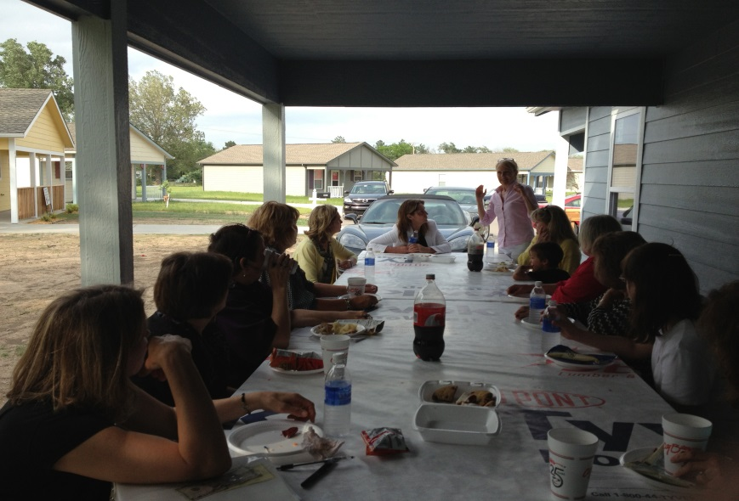

**THANK YOU to Wichita Habitat for Humanity and Director Ann Fox for hosting May’s NAWIC meeting on the patio at 4229 S. Ellis Court. Informative and fun!**



Everyone is invited to attend the 2nd annual fundraising event for HABITAT!!

You won’t want to miss this year’s event with construction themed games, live and silent auctions, and delicious entrees of Wichita’s finest smoked meats! $50/person

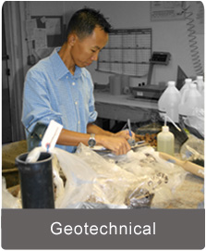

A big thank you is extended to Gregg Armstrong and David Edwards, GSI Engineering, for hosting the June NAWIC meeting at their offices, 4503 East 47th Street South!!!

(Gregg is the husband of our president-elect Cheryl Armstrong!)



**The Volunteer Day for Sgt. James “Matt” Amos  
is Saturday August 3, 2013 from 8:30 am -12:00 pm!**

We're ready to install the landscaping plan for the Sgt. Amos home and need your help to get the job done!   
Please bring your shovels, gloves, rakes and handheld gardening tools.  
Don't have work gloves?   
Buy Homes for Our Troops gloves on site for $10 and each donation will go toward Sgt. Amos’ home!

Join us **Saturday August 3, 2013** to help plant flowers, spread mulch, and install sod for this home.  
We'll be starting at 8:30am and going until the job is done!  
  
  
**Address:**[25011 South Haven Road, Mount Hope, Kansas](https://maps.google.com/maps?q=25011+south+haven+road,+mount+hope,+kansas&oe=utf-8&client=firefox-a&hnear=25011+S+Haven+Rd,+Mt+Hope,+Kansas+67108&t=h&z=16)



For more information,   
please contact **Doreen Lewis** at [**Dlewis@HFOTusa.org**](mailto:Dlewis@HFOTusa.org)

[Doreen Lewis](mailto:dlewis@hfotusa.org)

Community Outreach Coordinator Supervisor

[Homes for our Troops](http://www.hfotusa.org/)

6 Main Street

Taunton, MA 02780

phone: 508-823-3300 Fax: 508-823-5411

<http://www.HFOTusa.org>



The July meeting of NAWIC was hosted by our own NAWIC members, Lora Schmidt and Tracy Rasmussen along with guest speaker and owner, Ken Stoppel.

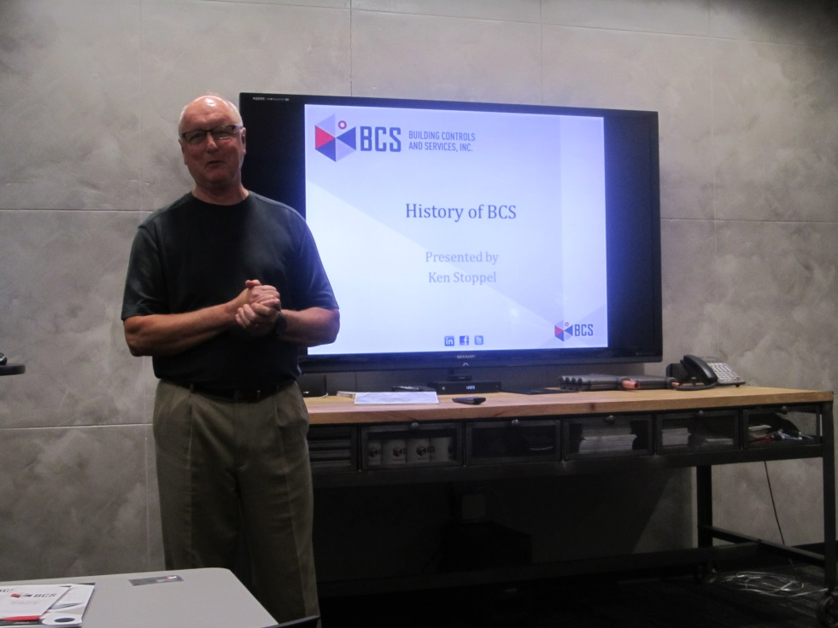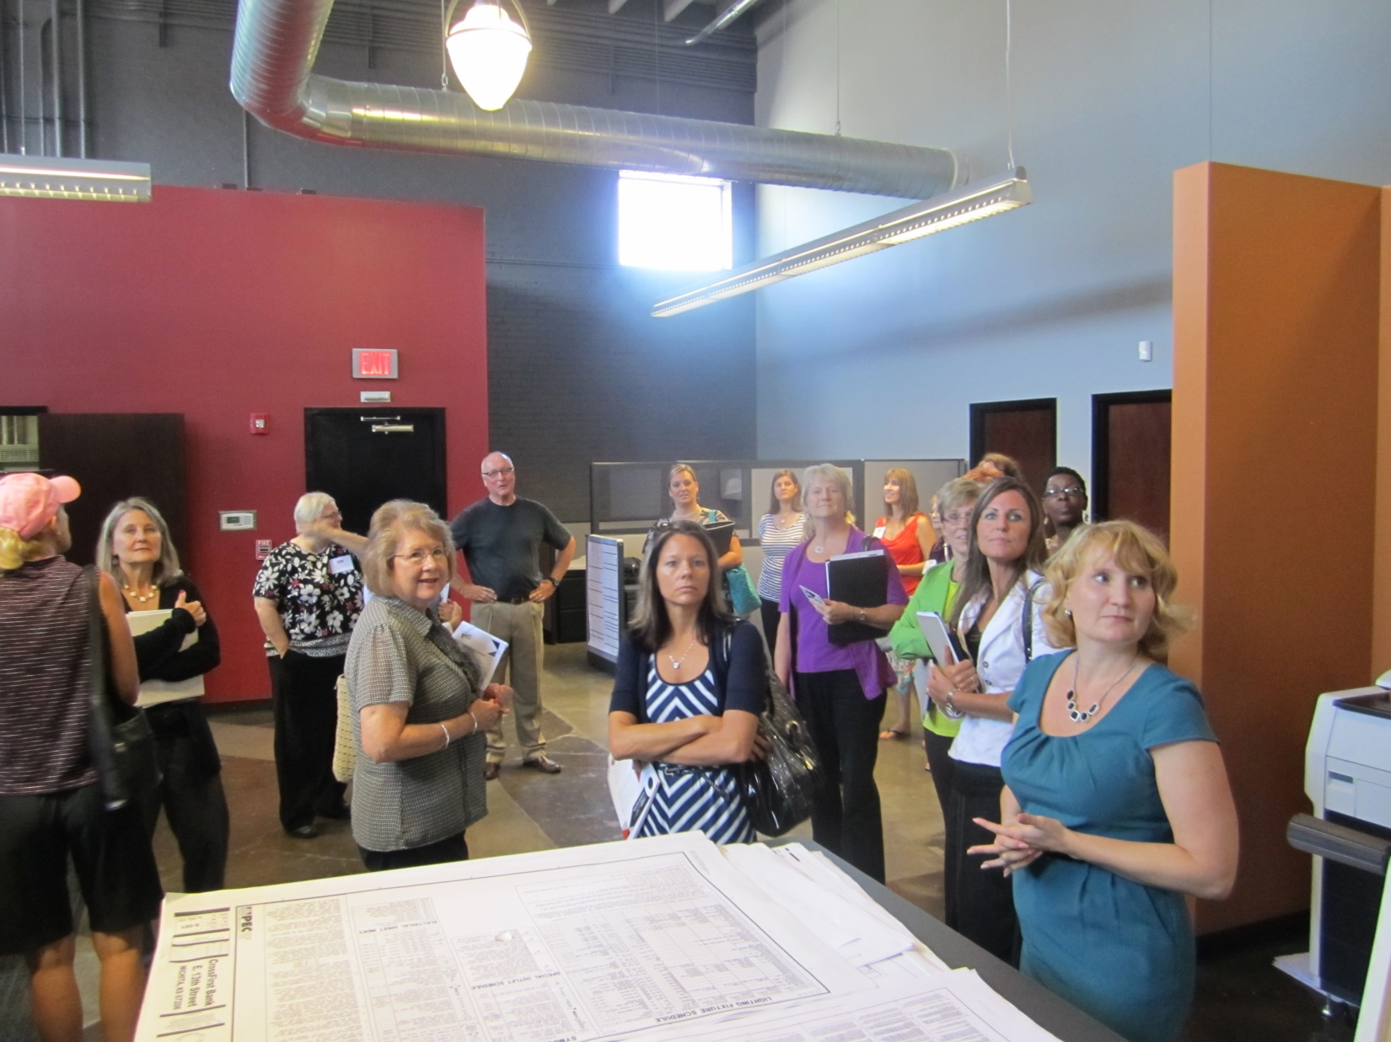

CONGRATULATIONS TO OUR NEWLY ELECTED OFFICERS

**President Cheryl Armstrong, EMC Companies**

Vice President Beverly Sauerwein, Sauerwein Constr.

**Secretary Sue Gleason, Comfort Systems**

Treasurer Jill Martin, Hentzen Contractors

**Director, Membership Chair Julie Kauffman, Kennedy & Coe**

**Director, Golf Committee, Joyce Reyes, CMC**

**Director, Lora Conger-Schmidt, BCS** Our purpose is to enhance the success of women in the construction industry.



**Check-out our website: Nawic Wichita.org**

(Thank you, June Huie!)



**Thank you to our Regional Director,**

**Bev Sauerwein,**

**for all of your service and support this year!!!**